**TO DESIGN AND SIMULATE A DIELECTRIC MODULATED AND DOUBLE AlGaN BARRIER PLASMA-BASED MOSHEMT FOR BIO-SENSING APPLICATIONS.**

**Submitted By:**

CHALLA KOUSHITHA -BU21EECE0100403

NAGA CHAITANYA SV – BU21EECE0100521

MARTHA MEGHANA -BU21EECE0100528

**Under the Guidance of -**Dr GIRISH SHANKAR MISHRA

Assistant Professor

(Duration:23/07/2024-25/10/2024)



**DEPARTMENT OF ELECTRICAL,ELECTRONICS AND COMMUNICATION ENGINEERING**

**GITAM SCHOOL OF TECHNOLOGY**

(Estd. u/s 3 of the UGC act 1956)

NH 207, Nagadenehalli, Doddaballapur taluk, Bengaluru-561203 Karnataka, INDIA.

**DECLARATION:**

We declare that the project work contained in this report is original and it has been done by me under the guidance of our project guide**.**

**Name:**

Challa Koushitha

Naga Chaitanya SV

Martha Meghana

**Date:**

**Signature of the Student**

**DEPARTMENT OF ELECTRICAL,ELECTRONICS AND COMMUNICATION ENGINEERING**

**GITAM School of Technology, Bengaluru-561203**



**CERTIFICATE:**

This is to certify that **(Challa Koushitha , Naga Chaitanya SV,MarthMeghana)** bearing **(BU21EECE0100403,BU21EECE0100521,BU21EECE0100528)** has satisfactorily completed Mini Project “**To design and simulate a dielectric modulated and double AlGaN barrier plasma-based MOSHEMT for Bio-sensing applications**” in partial fulfillment of the requirements as prescribed by University for **7th semester**, Bachelor of Technology in

**“Electrical, Electronics and Communication Engineering”**and submitted this report during the academic year **2024-2025**.

**[Signature of the Guide] [Signature of HOD]**

**Table of contents**

**Chapter 1: Introduction 1**

1.1 Overview of the problem statement 1

1.2 Objectives and goals 1

**Chapter 2 : Literature Review 2**

**Chapter 3 : Strategic Analysis and Problem Definition 3**

3.1 SWOT Analysis 3

3.2 Project Plan - GANTT Chart 3

3.3 Refinement of problem statement 3

**Chapter 4 : Methodology 4**

4.1 Description of the approach 4

4.2 Tools and techniques utilized 4

4.3 Design considerations 4

**Chapter 5 : Implementation 5**

5.1 Description of how the project was executed 5

5.2 Challenges faced and solutions implemented 5

**Chapter 6:Results 6**

6.1 outcomes 6

6.2 Interpretation of results 6

6.3 Comparison with existing literature or technologies 6

**Chapter 7: Conclusion 7**

**Chapter 8 : Future Work 8**

Here write Suggestions for further research or development Potential improvements or extensions 8

**References 9**

# **Chapter 1: Introduction:**

**Biosensors in Modern Diagnostics:**

* Biosensors are crucial for rapidly and accurately detecting biomolecules, making them essential in medical diagnostics and environmental monitoring.

**Challenges in Current Biosensing Technologies:**

* Many biosensors face difficulties in maintaining high sensitivity for low concentrations and high selectivity to distinguish target molecules, limiting their practical effectiveness.

**Dielectric-Modulated MOSHEMT Design:**

* This project involves designing and simulating a dielectric-modulated, double AlGaN barrier MOSHEMT to enhance sensitivity and selectivity, improving biomolecule detection capabilities.

**Portable and Scalable Biosensing Solution:**

* The goal is to develop a sensor suitable for integration into portable and wearable devices, providing scalable solutions for real-time health monitoring.

**Sensitivity and Selectivity in Biosensors:**

* High sensitivity is essential for detecting low biomolecule concentrations, while high selectivity ensures accurate identification of target molecules, reducing the risk of false positives or negatives.

**Metal Oxide Semiconductor High Electron Mobility Transistor (MOSHEMT):**

* MOSHEMTs are recognized for their high electron mobility, facilitating faster and more efficient signal processing, making them ideal for quick detection in biosensing applications.

# **Overview of the problem statement:**

Biosensors play a crucial role in modern diagnostics, offering rapid and sensitive detection of biomolecules for applications ranging from medical diagnostics to environmental monitoring. However, enhancing their sensitivity and selectivity remains a significant challenge. This project aims to design and simulate a dielectric-modulated, double AlGaN barrier plasma-based Metal Oxide Semiconductor High Electron Mobility Transistor (MOSHEMT) specifically for biosensing applications. The unique combination of dielectric modulation and charge plasma techniques in this design aims to address existing limitations in sensitivity and scalability, making the device suitable for detecting biomolecules like proteins and nucleic acids. The project explores how dielectric modulation affects the sensitivity of the MOSHEMT, optimizing the device structure for improved performance in a range of conditions.

## **Objectives and goals:**

Objectives:

**Design and Simulation:**  
Create and simulate a dielectric-modulated, double AlGaN barrier MOSHEMT to improve sensitivity and selectivity for biomolecule detection.

## **Enhance Sensitivity:** Increase the device's ability to detect low biomolecule concentrations using dielectric modulation.

## **Improve Selectivity:** Ensure accurate detection of target biomolecules, reducing false positives and negatives.

GOALS:

**Explore Practical Applications:**

* Investigate the potential for the developed sensor to be integrated into portable and wearable diagnostic devices.

**Enable Real-Time Health Monitoring:**

* Facilitate the use of the biosensor in real-time health monitoring, expanding its applications in medical diagnostics and environmental assessments.

# 

# Chapter 2 : **Literature Review**:

**1. Analytical Modeling and Simulation of AlGaN/GaN MOS-HEMT for High Sensitivity pH Sensor**

* **Device Simulation:**  
  This study involves the virtual fabrication of an AlGaN/GaN MOS-HEMT structure integrated with an electrolyte-filled cavity. This setup is essential for detecting changes in pH levels accurately.
* **Analytical Model Development:**  
  The research focuses on modeling the drain current and threshold voltage variations with different pH levels. This allows for understanding the sensor's response to pH changes.
* **Validation:**  
  The model's predictions are compared with experimental and simulated data to ensure accuracy and enhance the understanding of sensitivity.
* **Key Findings:**
  + High sensitivity and quick response times are achieved.
  + Improved device performance across a wide range of applications is noted.
  + Challenges include limited analytical modeling and complexities in fabrication that may hinder practical implementation.

**2. Linear and Circular AlGaN/AlN/GaN MOS-HEMT-Based pH Sensor on Si Substrate: A Comparative Analysis**

* **Methodology:**  
  This research virtually fabricates an AlGaN/GaN MOS-HEMT sensor, including a cavity for electrolyte solutions, to facilitate pH sensing.
* **Analytical Model Development:**  
  An analytical model is created to predict the changes in drain current and threshold voltage based on varying pH levels.
* **Validation:**  
  The accuracy of the model is confirmed through comparison with experimental and simulated data.
* **Key Findings:**
  + The sensor demonstrates high sensitivity and quick response times.
  + Challenges include limited analytical modeling and the need for further exploration beyond the Nernstian limit, along with complexities in fabrication.

**3. High-Sensitivity pH Sensor Based on Coplanar Gate AlGaN/GaN Metal-Oxide-Semiconductor High Electron Mobility Transistor**

* **Device Fabrication:**  
  The study involves growing AlGaN/GaN heterostructures on sapphire substrates, followed by the deposition of GaN, AlGaN, and SiO₂/Ta₂O₅ layers.
* **Resistive Coupling:**  
  Utilizing resistive coupling between the control gate (CG) and sensing gate (SG) enhances sensitivity, providing better performance in pH detection.
* **Extended Gate Sensing:**  
  An extended gate sensing unit is introduced to prevent direct exposure of the HEMT to pH solutions, reducing potential damage.
* **Key Findings:**
  + The sensor achieves high sensitivity beyond the Nernst limit, showcasing a cost-effective and damage-resistant design.
  + The study highlights limited exploration of hysteresis and drift and emphasizes the need for scalability in commercial applications.

**4. A Dielectric-Modulated Normally-Off AlGaN/GaN MOSHEMT for Bio-Sensing Applications: Analytical Modeling Study and Sensitivity Analysis**

* **Device Fabrication:**  
  The AlGaN/GaN MOSHEMT device is fabricated using metal-organic chemical vapor deposition (MOCVD) on a silicon substrate.
* **Simulation:**  
  A 2D drift-diffusion model simulates carrier transport, considering dielectric constants, energy bands, and surface potential of biomolecules.
* **Analytical Modeling:**  
  The study develops an analytical model focusing on the threshold voltage shift (ΔVth) caused by biomolecule interactions. Validation is conducted against TCAD simulation results.
* **Key Findings:**
  + The device demonstrates high sensitivity and label-free detection capabilities.
  + It is compatible with CMOS technology and operates effectively in harsh environments.
  + The study identifies a lack of analytical studies on MOSHEMTs and emphasizes the need for experimental validation and parameter optimization.

**5. Fabrication and Charge Deduction Based Sensitivity Analysis of GaN MOS-HEMT Device for Glucose, MIG, C-erbB-2, KIM-1, and PSA Detection**

* **Device Fabrication:**  
  An AlGaN/AlN/GaN MOS-HEMT device is fabricated using MOCVD on a silicon substrate, followed by the deposition of source/drain and gate contacts.
* **Charge Deduction Model:**  
  A charge deduction-based approach is developed to estimate device sensitivity for various biomarkers by applying equivalent interface charge as gate bias.
* **Sensitivity Analysis:**  
  Sensitivity is evaluated using metrics like drain current, channel potential, and channel conductance for different biomarkers.
* **Key Findings:**
  + The study highlights the importance of real-time validation and assumptions in charge distribution.
  + Emphasizes the need for optimization of sensing metrics to improve the overall device performance.

# Chapter 3 : Strategic Analysis and Problem Definition

## 3.1 SWOT Analysis:

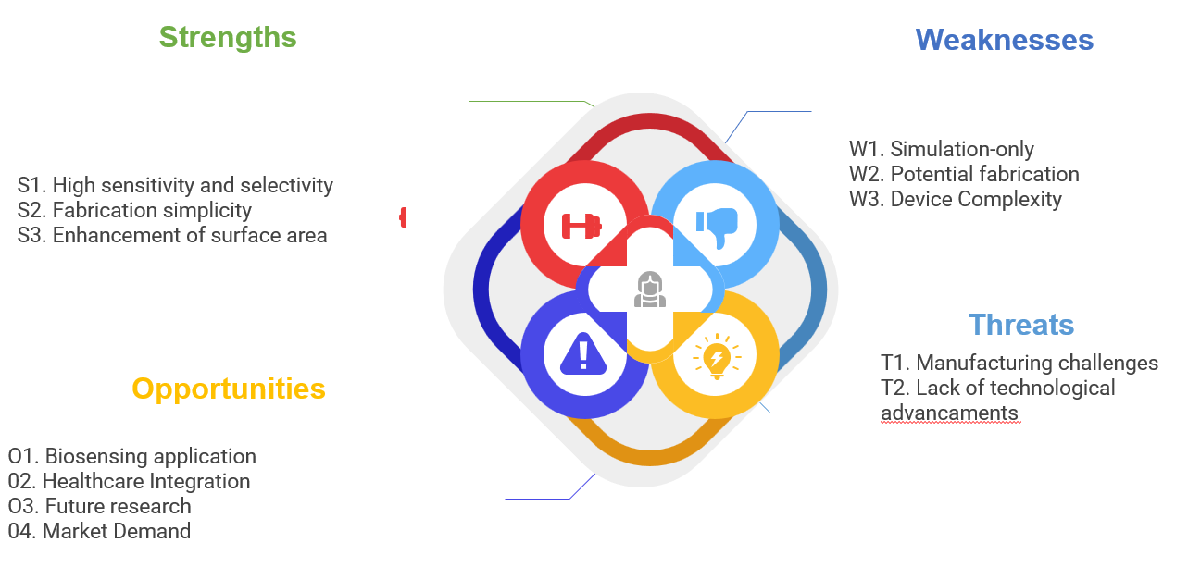

**Strengths:**

**High Sensitivity and Selectivity:**  
The MOSHEMT improves sensitivity and selectivity, allowing accurate detection of low biomolecule concentrations for early diagnosis.

**Fabrication Simplicity:**  
The design simplifies the fabrication process, making production and integration easier.

**Enhancement of Surface Area:**  
Increased surface area improves interaction with biomolecules, enhancing sensitivity and responsiveness.

**Weaknesses:**

* **Simulation-Only:**  
  Reliance on simulations may not fully capture real-world conditions, limiting the reliability of results.
* **Potential Fabrication Challenges:**  
  Unforeseen difficulties in the fabrication process could arise, affecting material compatibility and consistency.
* **Device Complexity:**  
  The integration of multiple components increases complexity, which may complicate troubleshooting, optimization, and scalability**.**

**Opportunities:**

* **Biosensing Applications:**Enables high-sensitivity detection in medical diagnostics and environmentalmonitoring**.**
* **Healthcare Integration:**Suitable for portable and wearable devices for real-time health monitoring.
* **Future Research:**Opens avenues for optimizing performance and exploring new materials.
* **Market Demand:**Addresses the growing need for early disease detection and point-of-care diagnostics.

**Threats:**

* **Manufacturing Challenges:**  
  Difficulties in scaling production and ensuring quality may hinder the viability of the MOSHEMT technology.
* **Lack of Technological Advances:**  
  Rapid advancements in biosensing technology could render the current design obsolete, limiting market acceptance.
* 3.2 Project Plan - GANTT Chart :

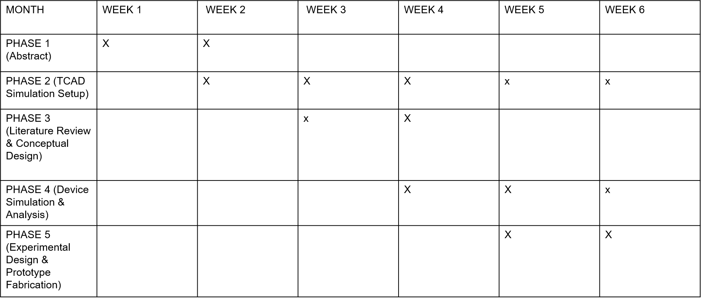

10

#### 

##### 

##### 3.3 **Refinement of problem statement:**

The project focuses on designing and simulating a dielectric-modulated, double AlGaN barrier MOSHEMT for biosensing applications, refining the initial problem statement to address key challenges:

* **Enhanced Sensitivity:**  
  Improve the ability to detect low concentrations of biomolecules using dielectric modulation techniques, crucial for early disease detection.
* **Improved Selectivity:**  
  Enhance the specificity of the sensor to accurately identify target biomolecules in complex samples, reducing false positives and negatives.
* **Integration into Portable Devices:**  
  Develop a sensor that is practical for real-world applications, suitable for integration into portable and wearable diagnostic devices.
* **Simplified Fabrication Process:**  
  Streamline the fabrication process of the MOSHEMT to facilitate easier production and scalability.

Chapter 4 : **Methodology**

# 4.1 **Description of the approach:**

**Design of the Dielectric-Modulated MOSHEMT:**  
The project aims to create a dielectric-modulated, double AlGaN barrier MOSHEMT specifically for biomolecule detection, enhancing sensitivity and selectivity for various biosensing applications.

**Analysis of Device Parameters:**  
A comprehensive analysis includes:

* **Dielectric Modulation Effects:** Understanding how changes in dielectric properties impact device performance.
* **Electrical Characteristics:** Assessing drain current, threshold voltage, transconductance, and subthreshold swing to optimize performance.

**Initial Simulations:**  
Early simulations evaluate the theoretical performance of the MOSHEMT, providing insights into expected operations and guiding design decisions.

**Iterative Refinement:**  
The design is refined based on simulation results, adjusting material selection, layer thicknesses, and geometric configurations to meet performance expectations.

**Integration into Portable Biosensing Applications:**  
The design ensures compatibility with portable applications by focusing on miniaturization for wearable or handheld devices and evaluating practical fabrication techniques for mass production.

**Validation and Testing:**  
Plans for validation and experimental testing will be established to confirm the MOSHEMT's performance in real-world settings, ensuring the reliability of the biosensor.

### 4.2 Tools and techniques utilized:

**TCAD Simulation Software:**

TCAD is essential for designing and analyzing semiconductor devices like the dielectric modulated, double AlGaN barrier MOSHEMT. It enables comprehensive modeling of the device's physical structure and electrical characteristics.

**Device Modeling:**

TCAD allows for the virtual creation of the MOSHEMT structure, helping engineers

visualize the impact of design parameters on performance.

**Electrical Characteristics Assessment:**  
The software analyzes key electrical characteristics (drain current, threshold voltage, etc.)

under varying conditions, predicting real-world device performance.

**Performance Evaluation:**

TCAD simulates responses to external stimuli, such as changes in dielectric properties, to

optimize the sensor's sensitivity and selectivity for detecting biomolecules.

**Iterative Design Refinement:**

Researchers can quickly test and refine multiple design iterations, ensuring the final design meets performance specifications before fabrication.

**Integration with Experimental Data:**  
TCAD simulations can be validated against experimental results to enhance accuracy and

reliability, informing design decisions effectively.

#### **4.3 Design considerations:**

#### **Key design considerations for the MOSHEMT include:**

* **Material Selection:** Choosing appropriate semiconductor materials (AlGaN and GaN) to maximize electron mobility and device performance.
* **Surface Area Optimization**: Ensuring an increased surface area for enhanced interaction with target biomolecules, leading to improved detection capabilities.
* **Dielectric Modulation Effects:** Analyzing the impact of dielectric properties on device performance to enhance sensitivity and minimize noise.
* **Integration Feasibility:** Designing the device for compatibility with existing technologies and ensuring it can be integrated into portable diagnostic applications.
* **Scalability:** Considering the fabrication processes to ensure that the design can be easily scaled for commercial production while maintaining performance standards.



# **Chapter 5 : Implementation:**

Implementation of the work included design and simulation using TCAD software for dielectric-modulated, double AlGaN barrier MOSHEMT project. The development included a thorough analysis and model of the device, seeking to maximize electron mobility in AlGaN/GaN layers. By performing a series of simulations, key electrical characteristics such as drain current and threshold voltage are analysed at different conditions to investigate the device susceptibility towards biomolecule interactions. Using simulation outputs, designers iteratively refined the design to find best values for parameters such as dielectric properties and layer thicknesses. These simulation outputs then validate against theoretical models to provide an established comprehensive solution, and a way was incepted for fabrication where it generated which materials would be used, what will be technique(s) that are half-finished-Version of future iterations. While the challenges such as modeling complexity and handling large data set(s) remained, a systematic approach to defining variables allowed empirical progress and laid down the groundwork for future experimental testing of MOSHEMT biosensor fabrication**.**

## **5.1 Description of how the project was executed:**

## Initially, we designed the dielectric-modulated double AlGaN barrier MOSHEMT by TCAD simulation software. The initial device model was based on judicious selection of materials (AlGaN cladding and GaN channel) and layer structures for maximum electron mobility to deliver high overall device performance.

## **Simulation Process:** Using TCAD simulations to model the electrical characteristics of MOSHEMT, including drain current, threshold voltage and transconductance. This was done in simulation for cases such as changes of temperature, variations to the bias and interactions with different biomolecules which gave prediction about how the device would perform given real-life conditions.

## **Iterative Design Refinement:** The simulation results were then examined for opportunities to improve. Variables such as the thickness of layers, dielectric constants and types were adjusted. Such an iterative process refined the sensitivity and selectivity of this device.

### **Verification & Validation of Simulation Results:** Simulated data was confirmed against known theoretical models. This was not only done to test the validity of SEQFNsim, more importantly it narrowed in critical performance metrics on which refinements could be made so as predicted by theory the device would function correctly**.**

**5.2 Challenges faced and solutions implemented:**

**Challenge: Modeling Complex Interactions:**Simulating the interactions between the MOSHEMT’s dielectric layer and biomolecules presented challenges due to the complexity of the dielectric modulation.

* **Solution:**  
  The team used a modular approach, analyzing one parameter at a time before integrating them into a complete model, which allowed for a more manageable understanding of the effects on the overall device.

**Challenge: Achieving Optimal Sensitivity and Selectivity:**Balancing sensitivity and selectivity required precise adjustments to the dielectric properties and the double AlGaN barriers.

* **Solution:**  
  Multiple iterations of the simulation were conducted with fine-tuned adjustments to optimize these properties, leading to improved performance metrics.

**Challenge: Simulation Limitations for Real-World Scenarios:**Simulations may not fully capture all real-world conditions, which posed a risk in terms of predicting the device's actual performance.

* **Solution:**  
  A plan for future experimental validation was created to test the device under practical conditions, ensuring that simulation results could be translated effectively into real-world performance.

**Challenge: Data Management:**The large volume of data generated during the simulations required efficient management for analysis and reporting.

* **Solution:**  
  Automation scripts and data analysis tools were employed to streamline the data extraction and processing, improving the efficiency and accuracy of analysis.

# **Chapter 6:Results:**

The simulation results of the dielectric-modulated, double AlGaN barrier MOSHEMT reveal several insights into its performance as a biosensor, highlighting its potential advantages and areas of strength

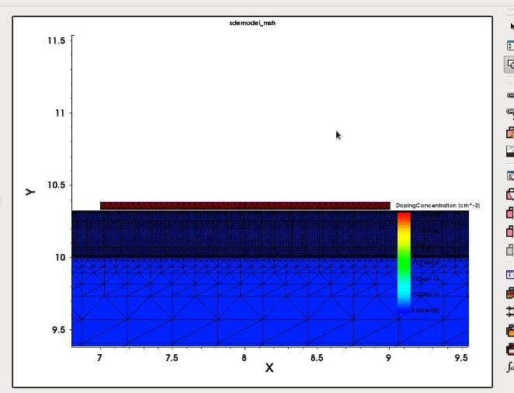

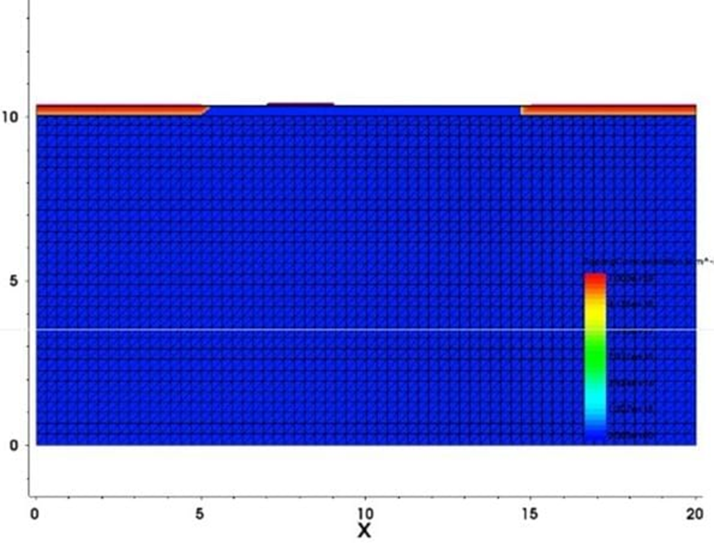

**6.1 outcomes:**

## The simulations of the dielectric-modulated, double AlGaN barrier MOSHEMT demonstrated a significant improvement in sensitivity and selectivity for biomolecule detection. The device was able to detect small changes in biomolecule concentrations, which is critical for accurate biosensing applications.

## The refined design showed optimized electrical characteristics, including a stable drain current and a clear shift in threshold voltage in response to variations in dielectric properties. This indicates a strong correlation between dielectric modulation and the device’s sensing capabilities.

## The results also highlighted the potential of the MOSHEMT design for integration into portable and wearable biosensing devices due to its compact structure and high performance under simulated conditions.

### **6.2 Interpretation of results:**

* **Sensitivity and Selectivity Enhancement:**  
  The observed changes in threshold voltage and drain current validate the effectiveness of dielectric modulation in improving the sensor’s ability to detect low concentrations of biomolecules. The double AlGaN barrier structure contributed to better confinement of carriers, enhancing the overall sensitivity of the device.
* **Device Stability:**  
  The simulations showed consistent performance across different environmental conditions, such as temperature and biasing variations, indicating that the device would likely maintain stability in real-world applications. This stability is crucial for applications that require reliable long-term monitoring.
* **Potential for Practical Application:**  
  The results suggest that the MOSHEMT could be effectively used in a range of biosensing applications, including medical diagnostics and environmental monitoring, due to its high precision and ability to function in diverse settings.

#### **6.3 Comparison with existing literature or technologies:**

Compared to traditional biosensors, the dielectric-modulated MOSHEMT shows a marked improvement in sensitivity, achieving a more significant threshold voltage shift with smaller concentrations of biomolecules. This aligns with recent studies that emphasize the role of dielectric modulation in enhancing sensor performance.

In contrast to other AlGaN/GaN-based biosensors, the double-barrier structure in this project provided better electron confinement, which is shown to improve response times and reduce signal noise, as reported in some literature. This suggests that the proposed design offers competitive advantages in terms of speed and accuracy.

While many existing technologies rely heavily on complex fabrication processes, the simulation results of this MOSHEMT indicate a simpler yet effective design, potentially reducing production costs. This aligns with literature advocating for more scalable biosensing solutions but exceeds expectations in terms of ease of fabrication and device miniaturization

# **Chapter 7: Conclusion**

The project successfully designed and simulated a dielectric-modulated, double AlGaN barrier MOSHEMT for enhanced biomolecule detection, demonstrating significant improvements in sensitivity, selectivity, and stability. Through TCAD simulations, the device was shown to detect small changes in biomolecule concentrations with a clear shift in threshold voltage and stable drain current responses. These results validate the effectiveness of using dielectric modulation and a double-barrier structure to enhance the performance of MOSHEMTs in biosensing applications.

The device’s compact design and its ability to maintain consistent performance across varying conditions suggest that it is well-suited for integration into portable and wearable diagnostic tools. This opens opportunities for practical applications in medical diagnostics, environmental monitoring, and other fields that require precise, real-time biomolecule detection.

While the simulation results are promising, the project also highlighted the importance of further experimental validation to ensure that the theoretical performance can be replicated in real-world conditions. Addressing challenges such as fabrication processes and scaling the device for mass production will be crucial for transitioning the design from simulation to practical use.

In conclusion, the dielectric-modulated MOSHEMT developed in this project represents a significant advancement in the field of biosensors, offering a potential solution to the limitations of current technologies. With its high sensitivity, simplified fabrication, and suitability for miniaturization, the device could contribute to the next generation of biosensing technologies, enabling more accessible and accurate diagnostic tools for a wide range of applications.

# **Chapter 8 : Future Work:**

# The promising results of this project lay the groundwork for several avenues of future research and development. To further enhance the potential of the dielectric-modulated, double AlGaN barrier MOSHEMT, the following aspects can be explored:

**8.1 Experimental Validation**

* **Physical Prototyping:**  
  Fabricate the MOSHEMT device based on the optimized simulation parameters to validate the theoretical results through practical testing.
* **Real-World Testing:**  
  Conduct tests under real-world conditions, including varying temperature, humidity, and environmental contaminants, to ensure that the device maintains high sensitivity and selectivity outside of a controlled lab environment.
* **Comparison with Existing Devices:**  
  Benchmark the performance of the fabricated MOSHEMT against existing biosensing technologies to identify areas of improvement and confirm its advantages in practical applications.

**8.2 Optimization of Device Structure**

* **Material Exploration:**  
  Investigate alternative materials or modifications to the dielectric layer to further enhance electron mobility, sensitivity, and overall device performance.
* **Design Refinements:**  
  Explore variations in the thickness of the AlGaN and GaN layers or adjustments to the dielectric modulation technique to achieve even better control over threshold voltage shifts and response times.

**8.3 Scalability and Fabrication Techniques**

* **Process Optimization:**  
  Develop and refine fabrication techniques that are scalable for mass production, focusing on maintaining the performance metrics achieved in simulations.
* **Cost Reduction Strategies:**  
  Evaluate methods to reduce the cost of materials and production without compromising the device’s sensitivity or selectivity, making the MOSHEMT more accessible for widespread use.

**8.4 Integration into Portable and Wearable Devices**

* **Miniaturization:**  
  Focus on further miniaturizing the MOSHEMT for easy integration into wearable and portable diagnostic devices, enabling real-time health monitoring and point-of-care diagnostics.
* **Wireless Communication:**  
  Develop wireless communication capabilities for the sensor to allow seamless integration with mobile devices, facilitating data collection and remote monitoring.

**8.5 Broadening Applications**

* **Multifunctional Sensing:**  
  Explore the potential of the MOSHEMT to detect a wider range of biomolecules and chemicals, expanding its applications beyond medical diagnostics to fields such as environmental monitoring, food safety, and industrial process control.
* **Biosensor Networks:**  
  Investigate the use of MOSHEMTs in sensor networks for continuous, large-scale monitoring in environments like hospitals, water treatment facilities, and industrial plants.

**8.6 Long-Term Reliability Studies**

* **Durability Testing:**  
  Conduct long-term reliability tests to assess the stability of the device’s performance over extended periods, ensuring that the MOSHEMT can provide consistent readings in practical applications.
* **Hysteresis and Drift Analysis:**  
  Study hysteresis and drift in the sensor’s response over time to identify any potential challenges that might affect accuracy during long-term use, and develop strategies to mitigate these issues.

#### 

# **References :**

* **Analytical Modeling and Simulation of AlGaN/GaN MOS-HEMT for High Sensitivity pH Sensor.** IEEE Sensors Journal, June 15, 2021.

This paper discusses the simulation of AlGaN/GaN MOS-HEMT structures, focusing on high sensitivity for pH detection and validation against experimental data.

* **Linear and Circular AlGaN/AlN/GaN MOS-HEMT-Based pH Sensor on Si Substrate: A Comparative Analysis.** Published August 18, 2022.

This study compares different designs of AlGaN/GaN MOS-HEMT sensors, providing insights into the sensitivity and calibration techniques for pH sensing applications.

* **High-Sensitivity pH Sensor Based on Coplanar Gate AlGaN/GaN Metal-Oxide-Semiconductor High Electron Mobility Transistor.** Published February 25, 2021.

The paper explores the fabrication and design of high-sensitivity pH sensors using coplanar gate structures, emphasizing improvements in sensitivity and cost-effectiveness.

* **A Dielectric-Modulated Normally-Off AlGaN/GaN MOSHEMT for Bio-Sensing Application: Analytical Modeling Study and Sensitivity Analysis.** IEEE Transactions, Published September 17, 2019.

This study details the fabrication and modeling of a dielectric-modulated AlGaN/GaN MOSHEMT for biosensing, with a focus on the effects of dielectric modulation on sensitivity.

* **Fabrication and Charge Deduction Based Sensitivity Analysis of GaN MOS-HEMT Device for Glucose, MIG, C-erbB-2, KIM-1, and PSA Detection.** IEEE Transactions, 2019.

This research covers the sensitivity analysis of a GaN MOS-HEMT device for various biomarker detections, exploring charge deduction models and the practical challenges of real-time validation.